

UNDERGRADUATE PROJECT REPORT

|  |  |
| --- | --- |
| **Project Title:** | **Web-based Earthquake Prediction system** |
| **Surname:** | **Zhao** |
| **First Name:** | **Yuyang** |
| **Student Number:** | **201918010226** |
| **Supervisor Name:** | **Dr. Joojo Walker** |
| **Module Code:** | **CHC 6096** |
| **Module Name:** | **Project** |
| **Date Submitted:** | **May 5, 2023** |

**Chengdu University of Technology Oxford Brookes College**

**Chengdu University of Technology**

**BSc (Single Honours) Degree Project**

Programme Name: **Computer Science**

Module No.: **CHC 6096**

Surname: **Zhao**

First Name: **Yuyang**

Project Title: **Web-based Earthquake Prediction system**

Student No.: **201918010226**

Supervisor: **Dr.** **Joojo Walker**

2ND Supervisor (if applicable): **Not Applicable**

Date submitted: **May 5, 2023**

*A report submitted as part of the requirements for the degree of BSc (Hons) in Computer Science*

*At*

**Chengdu University of Technology Oxford Brookes College**

**Student Conduct Regulations**:

Please ensure you are familiar with the regulations in relation to Academic Integrity. The University takes this issue very seriously and students have been expelled or had their degrees withheld for cheating in assessment. It is important that students having difficulties with their work should seek help from their tutors rather than be tempted to use unfair means to gain marks. Students should not risk losing their degree and undermining all the work they have done towards it. You are expected to have familiarised yourself with these regulations.

<https://www.brookes.ac.uk/regulations/current/appeals-complaints-and-conduct/c1-1/>

Guidance on the correct use of references can be found on www.brookes.ac.uk/services/library, and also in a handout in the Library.

The full regulations may be accessed online at <https://www.brookes.ac.uk/students/sirt/student-conduct/>

If you do not understand what any of these terms mean, you should ask your Project Supervisor to clarify them for you.

**I declare that I have read and understood Regulations C1.1.4 of the Regulations governing Academic Misconduct, and that the work I submit is fully in accordance with them**.

Signature:….ZhaoYuyang……………………………. Date ……………...2023/5/4………………............

REGULATIONS GOVERNING THE DEPOSIT AND USE OF OXFORD BROOKES UNIVERSITY MODULAR PROGRAMME PROJECTS AND DISSERTATIONS

Copies of projects/dissertations, submitted in fulfilment of Modular Programme requirements and achieving marks of 60% or above, shall normally be kept by the Oxford Brookes University Library.

**I agree that this dissertation may be available for reading and photocopying in accordance with the Regulations governing the use of the Oxford Brookes University Library.**

Signature ……ZhaoYuyang…………………….... Date ………….2023/5/4............................................

# **Acknowledgment**

First of all, I would like to thank my mentor Dr. Joojo Walker and I am writing to express my gratitude. In the past year, you have been my mentor. Your experience and knowledge have provided endless help to my study and career development. I remember feeling uncertain about the future direction when I first started the project. However, under your guidance, I gradually made my goal clear. You always encouraged me and patiently guided me to overcome the difficulties. Your support and encouragement made me full of confidence in the project and made a lot of progress. Besides, you also taught me how to manage my time. These skills are very important in my study and career, making me more confident and efficient. Therefore, I would like to take this opportunity to express my gratitude again. Thank you for your attention and support all the time. Your help has made me the person I am today. At the same time, I also want to thank the students who helped me in the project, especially my roommates, you all made great contributions.

# **Table of Contents**

**Acknowledgment** 3

**Table of Contents** 4

**Abstract** 5

**Abbreviations** 6

**Glossary** 8

**Chapter 1 Introduction** 9

**1.1** **Background** 9

**1.2** **Aim** 9

**1.3** **Objectives** 10

**1.4** **Project Overview** 10

**1.4.1** **Scope** 10

**1.4.2** **Audience** 10

**Chapter 2 Background Review** 11

**Chapter 3 Methodology** 13

**3.1** **Approach** 13

**3.2** **Technology** 19

**3.3** **Project Version Management** 20

**Chapter 4 Results** 21

**4.1** **Experimental Settings** 21

**4.2** **Model Training Results** 22

**4.3** **Web Application Development and Testing** 24

**Chapter 5 Professional Issues** 36

**5.1** **Project Management** 36

**5.1.1** **Activities** 36

**5.1.2** **Schedule** 38

**5.1.3** **Project Data Management** 39

**5.1.4** **Project Deliverables** 40

**5.2** **Risk Analysis** 40

**5.3** **Professional Issues** 43

**5.3.1** **Legal Issues** 43

**5.3.2** **Social and Ethical Issues** 43

**5.3.3** **Environmental Issues** 43

**5.3.4** **Project Implementation Issues** 44

**Chapter 6 Conclusions** 45

**6.1** **Reflections and Conclusions** 45

**6.2** **Future Work** 45

**References** 46

# **Abstract**

Earthquakes are a natural disaster and difficult to predict accurately. Earthquake prediction systems are designed to protect people's lives and property by monitoring, recording and analyzing seismic activity to provide the most accurate predictions and alerts possible. Earthquake prediction system is a scientific and technological means, which aims to predict the occurrence time, location, scale and other parameters of earthquake through the analysis and processing of geophysical data, as well as related mathematical models and algorithms. This website development project aims to create an earthquake prediction platform. Users can use an earthquake prediction software to meet the needs of users for earthquake prediction. Users can also use the site to learn about earthquakes. The site allows users to learn about all aspects of earthquakes, from earthquake prediction to analysis and survival.

***Keywords****: Earthquake, prediction, seismic data, web application development*

# **Abbreviations**

GPS: Global Positioning System

DLEP: A new deep learning model

LST: Local Standard Time

ANN: Artificial neural network

JSP: Java Server Page Java

# **Glossary**

**Earthquake Magnitude**: A measure of the amount of energy released by an earthquake, as determined by the size of the seismic waves that are generated.

**Seismic Wave**: A wave of energy that travels through the earth's crust and is generated by an earthquake or other seismic activity.

**Focal Depth**: The depth within the earth's crust where an earthquake originates, typically measured from the surface.

**Seismic Shear Wave**: A type of seismic wave that causes particles in the ground to move perpendicular to the direction of wave propagation. Shear waves can cause significant damage to buildings and infrastructure.

**Seismic P-Wave**: A type of seismic wave that causes particles in the ground to move back and forth parallel to the direction of wave propagation. P-waves are usually the first waves detected by seismographs following an earthquake.

**Speed**: The rate at which an object moves, typically measured in meters per second (m/s).

**Acceleration**: The rate at which an object changes its velocity, typically measured in meters per second squared (m/s²).

**Seismograph**: A seismograph is a scientific instrument that measures and records ground motion caused by earthquakes, volcanic eruptions, and other seismic sources.

**Satellite positioning system**: A satellite positioning system is a technology that uses satellites in orbit around the Earth to determine the location of a receiver on or near the Earth's surface. Examples include GPS (Global Positioning System) and GLONASS (Global Navigation Satellite System).

**Fault type**: Fault type refers to the classification of geological faults based on their movement direction and the type of stress that causes them. There are three main types of faults: normal faults, reverse faults, and strike-slip faults.

# **Introduction**

## **Background**

Earthquake is a terrible disaster for human beings, tens of seconds or even a few seconds mean life or death, if people can provide a software that can predict the earthquake, it can save many people's lives. Therefore, it should have a high degree of reliability and not allow the prediction to cause unnecessary panic, social and economic losses to the residents. But reliable predictions are difficult because the causes and patterns of earthquakes are still poorly understood. Seismologists cannot look directly into the Earth's interior, so they lack observational data on how earthquakes develop and the factors that affect them. So although the problem of earthquake prediction has been around for a long time, progress has been slow. Scientists around the world have made great efforts to do so, but they still can't predict earthquakes accurately and can only make very rough estimates at best. At present, the earthquake prediction system is mainly based on two methods: one is based on historical seismic data and statistical models, for example, the study finds the periodicity of earthquakes in a certain area, then the future seismic activity can be predicted according to these data; The other is based on seismic monitoring technology, such as using seismometer, GPS and other equipment to monitor crustal deformation, seismic activity and other information, through the analysis of these data to determine the earthquake risk. Although there is no perfect earthquake prediction system, scientists around the world are constantly improving the prediction accuracy and conducting more research. In short, earthquake prediction system is of great significance to protect human life and reduce the loss of earthquake disaster.

## **Aim**

The overall goal of this project is to develop a web application for earthquake prediction. This web application will help people survive earthquakes. The goal of earthquake prediction is to help people know the data about the next earthquake to help governments make plans, and to let people in the earthquake zone decide whether to take action. For example, to predict the earthquake magnitude or focal depth of the next earthquake to help people judge the degree of risk of the earthquake, so as to make a rational judgment. Earthquake knowledge is designed to give people a better chance of surviving an earthquake.

## **Objectives**

The objectives of this project are as follows:

1. ​To review existing web-based earthquake prediction systems.
2. Carry out an extensive requirement gathering and analysis of the earthquake prediction web application.
3. Collect relevant data for the earthquake prediction system.
4. Build the earthquake prediction algorithm.
5. Design and implement the frontend and backend systems of the web application.
6. Test and Evaluate the system's functionality to ensure it is useful for the intended audience.

## **Project Overview**

### **Scope**

The project is a web-based earthquake prediction system. The project uses machine learning to predict future earthquakes by inputting data from previous earthquakes. The model predicts the next earthquake in your area, including its size, depth, distance from you and how long it will take for the waves to reach your location. The program can help people better prepare for the threat posed by earthquakes.

### **Audience**

The software is aimed at residents and government workers in earthquake-prone areas. The software is also available to people in other fields who want to use it. After all, earthquakes can happen anywhere. Anyone in the earthquake zone can benefit from the software, as well as earthquake researchers.

# **Background Review**

1. True earthquake prediction (predicting before an earthquake occurs) is still in its infancy and its accuracy is very low. It is popular to use deep learning models for earthquake prediction. A new deep learning model called DLEP is used to predict earthquakes. In DLEP, explicit and implicit characteristics are effectively combined through suggested attention-based strategies(Li, 2020). In addition, a dynamic loss function is designed to deal with the classification imbalance of seismic data. The effectiveness of the DLEP compared to existing baselines, experimental results on eight data sets with different characteristics show that the proposed DLEP has good performance, which suggests that the idea of fusing explicit and recessive features is an effective solution for accurate earthquake prediction(Li, 2020). The DLEP's predictions are as follows.

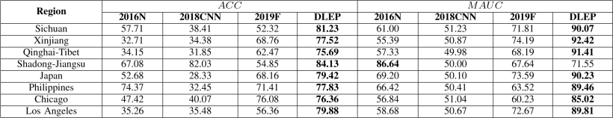

Figure 1: DLEP predicted results

There will be mistakes in predicting earthquakes through DLEP deep learning model. If the government issues forecasts through this model, if the forecast fails, it will cause a lot of unnecessary economic losses and panic of people and cause people's distrust of the government.

1. At presents the application of earthquake prediction is to pass when the earthquake somewhere, source would spread seismic wave, the earthquake early warning system is the use of electromagnetic wave transmission speed is greater than the characteristics of seismic wave, by reading the analysis setting in the real-time transmission of seismic monitoring stations around the recorded data, quickly to evaluate earthquake elements, and issue a warning. For example, the earthquake early warning mini program on WeChat. However, WeChat mini program has fewer functions, and it will also add popular science knowledge related to earthquake to help people in this program.
2. Satellite-based observations of abnormal increases in surface temperatures are another approach. Studies have found that there is an abnormal increase in surface temperature (LST) before the earthquake, called a thermal anomaly, which occurs about 1-24 days before the earthquake, with a temperature increase of 3-12K or more, and disappears after a few days. The first attempt to measure potential precursor LST phenomena was made in the 1980s, when soil temperature anomalies prior to the 1976 Tangshan earthquake in China were identified, and similar phenomena were identified in the Central Asian seismic region using satellite thermal infrared data, which has been used in many subsequent works(Zhang ,2017).

# **Methodology**

## **Approach**

**3.1.1 Earthquake prediction model**

Collect data: Gather a dataset of earthquake recordings from various sources, such as seismographs and GPS sensors. Preprocess data: Clean and normalize the data, remove any outliers or noise, and split it into training, validation, and test sets.Build a neural network: Design and train a neural network model using a programming language like Python. Choose appropriate hyperparameters, such as number of hidden layers, activation functions, and learning rate.Train the neural network: Use the training set to fit the model to the data. Monitor the model's performance on the validation set and adjust hyperparameters as needed.Test the neural network: Evaluate the model's performance on the test set.Predict earthquakes: Feed new earthquake data into the trained model to make predictions about future earthquakes. Evaluate and refine: Continuously evaluate the model's performance and refine the design and training process as necessary to improve accuracy.

**3.1.1.1 Foundation of mathematics**

The algorithm of earthquake prediction model in this website is based on Abrahamson and Youngs' paper "A stable algorithm for regression analyses using the random effect model". As mentioned in the above paper in this paper, the author proposes another algorithm for more stable although less efficient decay relationship regression problems used to focus on the discussion, but the algorithm is suitable for any application of the random effects model of the usual way to obtain the empirical decay relationship considered model for

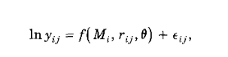

where yij is a ground motion parameter, f(Mi, rij, θ) is the attenuation equa-tion, M is the earthquake magnitude, r is the distance, θ is the vector of model parameters, and εij is the error term for the jth recording from the ith event and is assumed to be normally distributed. This type of model is called a fixed effects model because we are interested in the estimates of all of the dependencies that are considered (Abrahamson and Youngs, 1992).

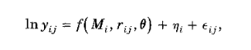At the same time, the paper also proposes a hybrid model, which includes fixed effects and random effects. Random effects explain the dependencies in the data we want to consider, but we do not want to explicitly estimate, for example, regression analyses where event items are estimated as intermediate steps because there is no interest in individual values for event items, however, if seismologists want to compare event items to better understand ground motion, then event items should be treated as fixed effects. For the mixed model, the error term is divided into two parts: the inter-event term and the intra-event term. The form of regression model is

where ηi is the random effect for the ith event. The ηi represent inter-event variations and the εij represent intra-event variations. The εij and ηi are assumed to be independent normally distributed variates with variances calculate model parameters and variances, respectively. At the same time, Brillinger and Prelisler proposed an expectation maximization algorithm to calculate model parameters and variance. The algorithm is an iterative process of continuously calculating random effects, variances and model parameter values. (Abrahamson and Youngs, 1992). The algorithm can be summarized as follows:

|  |
| --- |
| 屏幕截图 2023-04-27 113126  1. |
| 屏幕截图 2023-04-27 113151 |
| 屏幕截图 2023-04-27 113204  3. |
| 屏幕截图 2023-04-27 113216  4. |
| 屏幕截图 2023-04-27 113246 |

Table 1: Brillinger and Preisler's algorithm

The author of the paper on the new algorithm and the algorithm comparison Abrahamson and Youngs concluded The algorithm usually converges in less than 30 iterations. Comparing this algorithm with Brillinger and Preisler algorithms, it is found that the key difference is that the new algorithm does not include random estimation. The estimated random effects are only used for fixed-effect regression to estimate the new model parameters. As a result, unreasonable starting values of variances and model parameter values do not cause problems; They simply produce low probabilities. This algorithm is more stable than the algorithm given by Brillinger and Preisler when it is insensitive to the starting point. However, it is also more computationally intensive because step 2 cannot be analytically solved. For reasonable initial values, the two algorithms can tend to be the same result. We believe that the stability of the new algorithm makes it more suitable for general use. Using covariance can reduce the number of steps matrix of the algorithm in the first step instead of fixed effect regression.So this algorithm is due to the previous algorithm.

**3.1.1.2 Dataset collection**

By visiting the China earthquake networks - http://www.ceic.ac.cn/speedsearch query seismic data, check the network request can be found that path. From the analysis, we can see that each row of data is placed in the tr of the table in div. News-content. We use XPath Helper tools to locate the row data. In terms of data acquisition, Python Scrapy framework is used, which provides the base class of various types of crawlers, such as Base Spider and sitemap crawlers, etc. With the help of scrapy, we can easily crawl the website data, analyze and save the data (Wu, 2020).

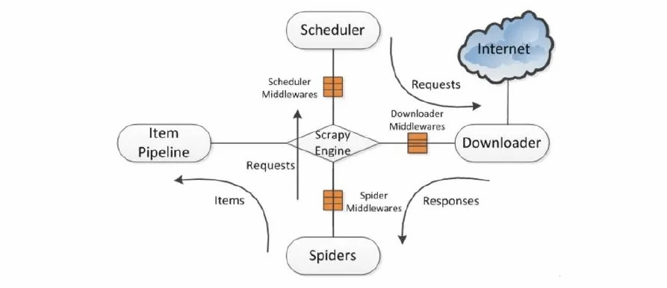

Figure 2 Python Scrapy framework

first crawl every line of the content, through the object, the hand in text matching that can extract the data, the data analysis to the model, then we need to model the data saved to the database in order to query and analysis in the future, the last program is responsible for the data model of data saved to the database. Here, the whole crawler process is over, scrapy framework can be used to easily crawl web data and analyze and save the data. Then we can build a crontab timer and execute the crawler program periodically. In this way, we can automatically crawl the information of the seismic network, save it in the database, and then forecast the earthquakes around users through the popup of the web page. Testing and evaluation process, the seismic data displayed by the software will be compared with the Chinese seismic network to see if they are consistent.

Combined with these techniques, the project can predict earthquakes, including where they will occur, when seismic waves will arrive, and where the earthquake will be centered. The project Using MATLAB model for earthquake prediction. Artificial neural network (ANN) combined with artificial intelligence has been used to solve a series of complex nonlinear problems effectively. The purpose of this study is to guide the training process of artificial neural networks, build a network model with two hidden layers, and determine the optimal number of neurons in each hidden layer to predict the magnitude of an upcoming earthquake. This involves retraining the network model with the new seismic catalog without requiring long computing time and relying on more initial input from the seismic catalog. Prediction errors are expected to be reduced as long calculation times are no longer required due to the use of earthquake catalogs covering a longer period of time. This is achieved without the use of local geological features and can be accomplished by using inversion methods to construct an artificial neural network of intelligent optimization training algorithms to determine the optimal number of neurons.

The algorithm of the earthquake prediction project can be written by summarizing the previous algorithm: See Appendix for detailed code. Based on Abrahamson and Youngs' paper "A stable algorithm for regression analyses using the random effect model", All earthquake prediction functions of the project are based on this algorithm.

**3.1.2 Web Application development**

**3.1.2.1Registration login function**

After entering the registration page, the user can fill in the data in the form according to the requirements, click the registration button, and send the input content to the background processing page Register by the way of asynchronous refresh. Action Writes data to the database. When passing the form, the system also calls the function check() function of JavaScript to check the data filled in the form. Once a data item in the form is found not to meet the requirements, the system will pop up an error message, prompting the user to fill in again. Page in the background processing, system definition corresponds to the first form of each data item variables, using the struts 2 configuration, to assign users to fill in the form of data to these variables, determine whether the user name already exists, there is data returned 2, 2 at the front desk to receive data, prompt the user name has already been copies, please fill in again, if use account is valid, but two password is not, Return data 1, received data 1 in the front desk, then prompt the user twice password inconsistent, please re-input, these data are correct, stored in the database when the variable value directly added to the database, and return data 4, received data 4 in the front desk prompts the user to register successfully. The user enters a user name and password in the correct format and clicks to log in. The front-end page determines whether the format of the information entered by the user is correct and legal. The client submits this information to the server, and the server gets all the content and extracts the required information. The server judges the information again, determines whether the format of the information entered by the user is correct and legal, and checks with the registered account information in the database to see whether the corresponding user name and password are equal. If the Page **8** of **12** check finds that the information is equal, the Cookie is set, and the client HTTP status code 200indicates that the registration is successful. If the check fails, the HTTP status code 401and the corresponding error message are returned to indicate the registration failure. If the client receives the 401status code, it will prompt the user to login failed and display the corresponding error message. If the client receives the 200status code, it will bring the received Cookie to initiate a request to the url of the home page. After receiving the request, the server parses the Cookie carried by the request and extracts the information of the user contained in the Cookie. Replace part of the public information in the home page with the user's own personal information, and return the replaced content to the client. The client shows the returned content to the user.

**3.1.2.2 The home page**

Use any editor to edit the homepage of the website, where index.html is the homepage and other html is the secondary page. Then use CSS files to edit page styles, text scrolling, pictures, etc. Finally, JS is used to realize dynamic rotation effects, form submission, click events and so on.

**3.1.2.3 The uploading of website content**

The front end uses JSP to write page styles. Text information is the use of a JS tool class, the user input information submitted to the back end. The uploaded information is first concatenated into a string at the front end, separated by commas. This way, it can be transferred to the back end and then analyzed. Uploaded images are submitted using jQuery's ajaxfile upload function. The front-end method of image transmission input the corresponding method in the controller when uploading the image, upload the image to the folder set by the server, and return the URL to the front-end, combine with the above text information, and send to the back-end for unified processing. The back end transfers it to the database through a process of controller, service, and mapper classes. The first is to receive text information from the front end. The second method is to receive the image information sent by the front end, including validation to determine the file type, then send it to your server, then return its URL, add the text information and send it to the database. The method that receives the text information calls the relevant method of the service interface. This method is implemented in the implementation class of the service. The function of this method is to parse the string passed in by the front end, use the set method in the pre-built entity class, call the related function in the mapper interface, and pass it to the database through the method in mapper.xml.

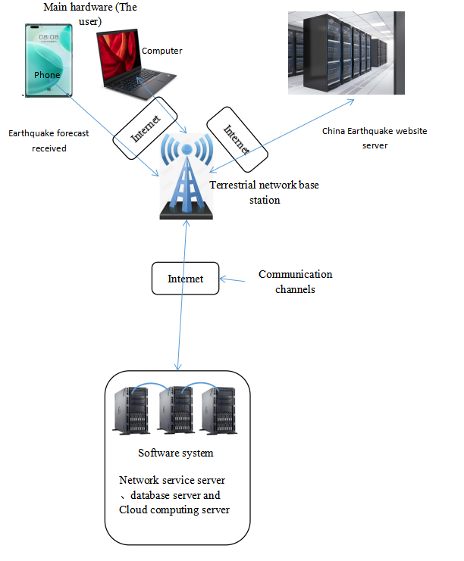

Figure 3 Construction of website

## **Technology**

|  |  |
| --- | --- |
| **System** | **Windows 10** |
| **CPU** | **Intel(R) Core(TM) i7-9750H CPU @ 2.60GHz 2.59 GHz** |
| **GPU** | **NVIDIA RTX 2060** |
| **Database** | **MySQL 8.0 Command Client** |
| **Programming Languages** | **Python matlab Sublime Text** |
| **Compiler** | **PyCharm 2022.2.4 matlab** |

Table 2: Technology

## **Project Version Management**

The project uses GitHub for version management. After you have finished writing the code or report, it will be uploaded to the corresponding category of the project in GitHub. If subsequent changes are made, the files for that section will be re-uploaded.

This project uses github to implement file management:

Weekly meeting logs: https://github.com/Eric917/Earthquake-Prediction/tree/main/Weekly%20meeting%20logs

Requirements or user stories:

https://github.com/Eric917/Earthquake-Prediction/tree/main/Requirements%20or%20user%20stories

Testing documentation:

https://github.com/Eric917/Earthquake-Prediction/tree/main/Testing%20documentation

Reports: proposal, interim, final:

https://github.com/Eric917/Earthquake-Prediction/tree/main/Reports:%20proposal%2C%20interim%2C%20final

Ethics forms:

https://github.com/Eric917/Earthquake-Prediction/tree/main/Ethics%20forms

Literature:

https://github.com/Eric917/Earthquake-Prediction/tree/main/Literature

# **Results**

## **Experimental Settings**

|  |  |
| --- | --- |
| Datasets Details | Appropriate tools are used to query seismic data from the China earthquake networks - http://www.ceic.ac.cn/speedsearch. The crawled data is processed into a "Data.mat" format. Data cleaning and data splitting into a train and test set is generated for training in the earthquake prediction model. |
| Model Training Parameter Settings | The data in the data set is divided into eight parameters, namely Serial number, Earthquake magnitude, deistic, Focal depth of earthquake, Ground parameter1, Ground parameter2, Fault type and PGA.PGV\IA value.  屏幕截图 2023-05-06 172916 |

Table 3: Experimental Settings

## **Model Training Results**

After establishing the model in MATLAB, the result prediction is as follows:

Prediction Model Training Results

|  |  |
| --- | --- |
| Expected Results | Values |
| P-Wave detection time for threshold 4 | 72.310000 seconds |
| P-Wave detection time for threshold 3 | 66.330000 seconds |
| S-wave found on EW component | 72.580000 seconds |
| S-wave found on NS component | 72.315000 seconds |
| First position of S-wave detection | North-South component |
| Distance of Earthquake from seismometer | 0.0400000 kilometers |

The model will draw pictures related to the earthquake, including: Displacement of the seismometer in 3D, Display seismic wave detailed data, Image of Displacement of the seismic wave. After the above functions are implemented, the model will stop running.

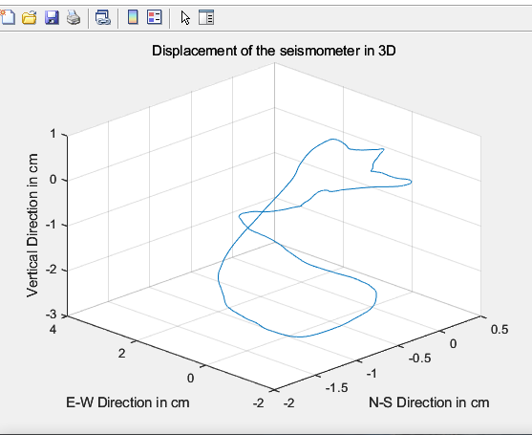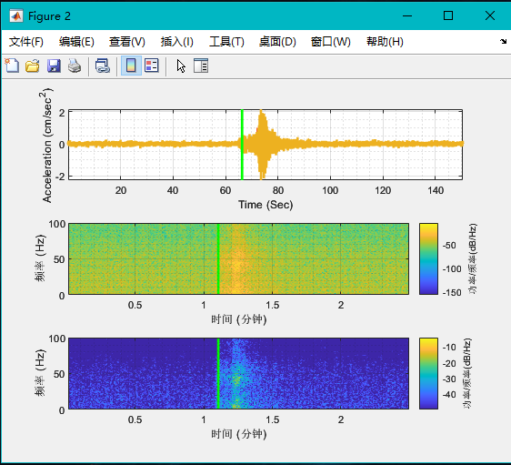

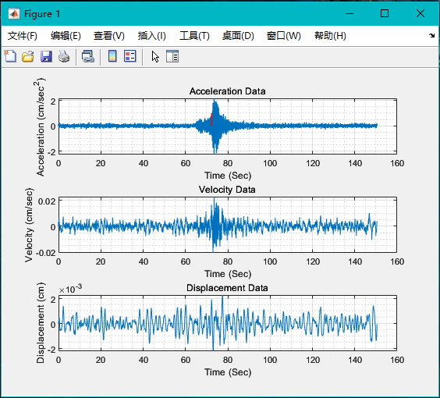

## **Web Application Development and Testing**

**In the Tables below, the implemented project is tested and evaluated in several cases:**

|  |  |
| --- | --- |
| Case | Registration and login test |
| Type of test | Functional testing |
| Step | 1. Click the sige up button. 2. Input a username 12345@qq.com. 3. Input a password 12345. 4. Click the submit button. 5. Click the sige in button. 6. Input a username 12345@qq.com. 7. Input a password 12345. 8. Click the sige in button |
| Input data | username 12345@qq.com.  password 12345. |
| Expected results | register and login succeeded |
| Actual results | 图片8 |
| Conclusion | The login and register function test successfully with no problems. |

Table 4: Test Registration and login Function

|  |  |
| --- | --- |
| Case | Home page test |
| Type of test | Functional testing |
| Step | Click Home page |
| Expected results | Home page displayed successfully |
| Actual results | 图片6 |
| Conclusion | Home page function test successfully with no problems. |

Table 5: Test Home page

|  |  |
| --- | --- |
| Case | Seismic data reading test  This function loads the data set of the artificial neural network to predict earthquakes, allowing the project to successfully load the data to start operating |
| Type of test | Functional testing |
| Step | Load the data by clicking data.mat file |
| Expected results | Read display success |
| Actual results | 屏幕截图 2023-05-05 091634 |
| Conclusion | Seismic data reading test function test successfully with no problems. |

Table 6: Data reading

|  |  |
| --- | --- |
| Case | Test of earthquake prediction function |
| Type of test | Functional testing |
| Step | Click the Start Prediction button |
| Expected results | The earthquake was successfully predicted, and the pictures and data after the prediction were displayed |
| Actual results |  |
| Conclusion | Earthquake prediction function is successful, no problem |

Table 7: earthquake prediction function 1

|  |  |
| --- | --- |
| Case | Test of earthquake prediction function 2 |
| Type of test | Functional testing |
| Step | Displacement of the seismometer in 3D is displayed successfully |
| Expected results | Displacement of the seismometer in 3D was successfully generated and the image was displayed |
| Actual results | 屏幕截图 2023-05-05 092341 |
| Conclusion | Displacement of the seismometer in 3D function is successful, no problem |

Table 8: earthquake prediction function 2

|  |  |
| --- | --- |
| Case | Test of earthquake prediction function 3 |
| Type of test | Functional testing |
| Step | Display seismic wave detailed data function |
| Expected results | Displacement of the seismic wave was successfully generated and the image was displayed |
| Actual results | 屏幕截图 2023-05-05 092356屏幕截图 2023-05-05 092326 |
| Conclusion | Displacement of the seismic wave function is successful, no problem |
| discussion of results | The project's earthquake prediction technology still has many limitations. Here are some examples of these limitations:Uncertainty: Current earthquake prediction techniques do not fully predict when, where, or how strong an earthquake will occur. Although scientists use a variety of physical and geochemical models to try to predict earthquakes, many predictions are subject to great uncertainty because the Earth's interior is so complex and difficult to observe. At the same time, the project's predictions and simulations, which are based mainly on detailed seismic data, are lacking in accuracy |

Table 8: earthquake prediction function 3

|  |  |
| --- | --- |
| Case | Test of earthquake prediction function 4 |
| Type of test | Picture preservation |
| Step | After the earthquake prediction is completed, the system will automatically save the images generated by the prediction in the pre-set 'results' folder |
| Expected results | A pre-set 'results' folder will display images of earthquake predictions |
| Actual results | 屏幕截图 2023-05-05 113323 |
| Conclusion | The picture saving function succeeded. Procedure |

Table 9: earthquake prediction function 4

**Summary of results**

Artificial neural network can be used for earthquake prediction. Its basic idea is to use the data of historical seismic events as input vector, and corresponding to different target output of the occurrence and non-occurrence of earthquakes respectively.

Specifically, the seismic data within a certain area is collected, including seismic waveform, focal mechanism and other parameters, and combined with the law of historical earthquake occurrence, artificial neural network is used to learn and train, and then predict the future possible seismic events. In the training process, it is necessary to fully consider the influence of various factors, such as geological structure, groundwater level, stress distribution, etc., in order to improve the accuracy of prediction.

It should be noted that there are still many challenges and limitations in earthquake prediction of artificial neural network, such as lack of sufficient data and too complex model, so its prediction results need to be further verified and improved.

# **Professional Issues**

## **Project Management**

### **Activities**

|  |  |  |
| --- | --- | --- |
| A | Analysis of existing functions and requirements.  Reading literature Study | Completed  Completed |
| B | Design the program UI interface | Completed |
| C | User database design  Database design of earthquake | Completed  Completed |
| D | Project home page code writing | Completed |
| E | Main project code writing | Completed |
| F | User database establishment  Earthquake database building | Completed  Completed |
| G | Seismic real-time data reading | Completed |
| H | Project Test | Completed |
| I | Writing the final report.  Design the PPT for final presentation.  Show the project to the audience. | Completed  Completed  Completed |

Table 10: Activities

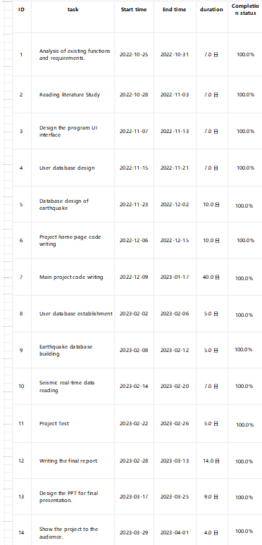The project was planned and a Gantt chart drawn, to show tasks within the schedule, Figure 5.1. The project was managed according to the schedule.

Table 11: Project Management

### **Schedule**

This project uses Gantt chart as a management tool to display the project progress and schedule. It arranges tasks on a timeline in the form of a horizontal bar chart and identifies the relative position and duration of each task. A Gantt chart can help team members better measure progress by helping them understand the start and end times, duration, and sequence of each task in a project.

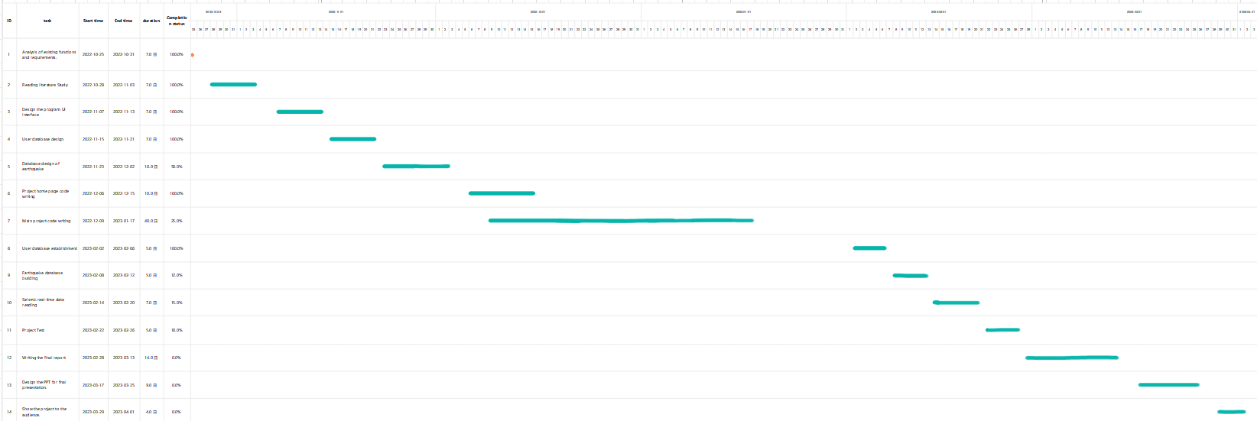

Figure 4: Gantt

### **Project Data Management**

As each version of the code is complete, the project uploads the results to the github repository. The steps are as follow and URL is https://github.com/Eric917/Earthquake-Prediction Sign up for an account on github.com.

First, you need to create a GitHub account. Once created, you are ready to create and manage the project.

Create a new warehouse

On the GitHub page, click the "+" symbol in the top right corner, then select "New repository." Enter the name of your project in the "Repository name" field and select any other Settings you want. Then click the "Create repository" button to create a new repository.

Clone code

On the project page, click the green "Code" button, then select the HTTPS or SSH link. After copying the link, use the git clone command on the local terminal to clone the project locally.

Add, commit, and push changes

After you make changes to your code locally, you need to upload those changes to a remote repository. The first thing you need to do is add your changes to the local staging area, using the command git add. (A dot means add all your changes to the staging area.) Then use the git commit command to commit your changes and add comments. Finally, use the git push command to push the changes to the remote repository.

Branch management

Create branches to manage different code versions and functional modules. Create a new branch using the command git branch new branch name and switch to it using the git checkout new branch name command. After making changes on the new branch, push them to the remote repository.

Merged branch

When the code in one branch is done and tested OK, it can be merged into the main branch

### **Project Deliverables**

1. Undergraduate Project Proposal (submitted)

2. Progress report (this report)

3. Final report

4. Earthquake prediction system

5. Powerpoint presentation of earthquake prediction system

## **Risk Analysis**

Risk analysis is an important aspect of earthquake prediction project. When risks are properly identified, mitigation strategies are properly implemented and reviewed regularly, the likelihood of negative impacts is reduced and the chances of them occurring are increased.

|  |  |  |  |  |  |  |  |
| --- | --- | --- | --- | --- | --- | --- | --- |
| **Risk ID** | **Potential Risk** | **Cause ID** | **Potential Causes** | **Severity** | **Likelihood** | **Risk** | **Mitigation** |
| R1.1 | Missed deadline | C1.1.1 | Suddenly came across something | 1 | 3 | 3 | Develop a contingency plan: Create a detailed action plan that outlines steps to mitigate the emergency, minimize damage, and get the project back on track. |
| C1.1.2 | Poor time management | 2 | 4 | 6 | Prioritize tasks: Determine critical tasks that need immediate attention, estimate the resources required, and allocate them strategically. |
| C1.1.3 | Forget to implement a function | 3 | 2 | 8 | Abandon the implementation of this function without affecting the other functions of the project |
| R 1.2 | Problems encountered during program development | C1.2.1 | The design is too complex in the planning phase | 3 | 2 | 6 | Revisit design requirements: Review the design requirements and determine if they are essential and necessary for the program's functionality.  Simplify the design: Identify areas where the complexity can be reduced by simplifying the design. Consider alternative approaches or solutions that could simplify the code. |
| C1.2.3 | Some code problems cannot be solved on your own | 4 | 4 | 16 | Discussing with supervisors or through online learning to solve problems |
| R1.3 | Software bugs | C1.3.1 | I encountered a bug while writing the code | 4 | 3 | 12 | Debug code: Use a debugger or logging statement to track the flow of code and determine where errors occur. Analyzing the code: I identified where the error occurred and examined the code for logical errors, syntax errors, and other issues that might have caused the error.  finally  Fix the bug: Once the root cause of the bug has been identified, fix it by modifying the code. |
| C1.3.2 | A problem was encountered during the testing of the program | 2 | 2 | 6 | Identify root cause: Reproduce the problem to identify the underlying cause. Discovery is a problem caused by incorrect code and accidental input  Fix the problem: Once the problem is found, a fix can be implemented to resolve the problem. |
| C.1.3.3 | During the development of the program, some features were found to be impractical | 3 | 3 | 4 | Evaluate the function: Determine why the function is not practical. Whether it is too complicated to implement. Then consider alternatives: Explore alternative ways to achieve the same functionality as the one in question. |
| R1.4 | Files or data are lost | C1.4.1 | A form was found missing while filing | 4 | 4 | 16 | Using the automatic file saving function of the WPS software, I found the file that was automatically saved a day ago and found a table in it |
| C1.4.2 | Data loss occurred while the model was running | 4 | 4 | 16 | I rewrote this section and learned my lesson. Back up your data: It's crucial to have a backup of your data before running an AI model. This ensures that if there is any data loss during the process, you can restore it from the backup. |
| C1.4.3 | Developer's computer can't work | 2 | 2 | 4 | Fix the computer and continue through the project data stored on GitHub |

Table 12: Risk Analysis

## **Professional Issues**

General problems of software development:

The development and implementation of an earthquake prediction project can raise several legal, social, ethical, and environmental issues.

### **Legal Issues**

Legal issues may include the need for proper permits and permissions, compliance with data protection laws, liability for inaccurate predictions, and adherence to local building codes. Social issues may arise due to the potential impact on communities in earthquake-prone areas. The project should consider the potential consequences of accurate or inaccurate predictions, including panic, fear, or complacency.

### **Social and Ethical Issues**

Ethical considerations include ensuring transparency and fairness in the distribution of information and resources related to the project, avoiding discrimination based on socioeconomic status or other factors, and protecting privacy rights when collecting and using data.

Professional codes of conduct, such as those issued by the British Computer Society (BCS) or the Association for Computing Machinery (ACM), provide guidance on ethical and professional standards that should be followed in any technological endeavor. In the context of an earthquake prediction project, these codes would emphasize the importance of accountability, transparency, and responsible decision-making, as well as the protection of human rights and the environment.

### **Environmental Issues**

Environmental concerns may involve minimizing any potential harm to the natural environment during the construction and operation of the project. The impact of earthquake prediction systems on the environment is enormous. For instance, little was understood about earthquakes until the emergence of seismology at the beginning of the 20th century. Seismology, which involves the scientific study of all aspects of earthquakes, has yielded answers to such long-standing questions as why and how earthquakes occur.

Earth’s major earthquakes occur mainly in belts coinciding with the margins of tectonic plates. This has long been apparent from early catalogs of felt earthquakes and is even more readily discernible in modern seismicity maps, which show instrumentally determined epicenters.

With the development of a web-based application for earthquake prediction, humans and animals in our environment can be saved from sudden destruction and death.

### **Project Implementation Issues**

Lack of available data: Earthquake data is relatively scarce and predicting earthquakes requires a large amount of historical data. Therefore, the lack of sufficient data can make it difficult to train an accurate neural network. Complexity of seismic signals: Seismic signals are complex and non-linear, which makes it challenging to extract meaningful features from them. This complexity can lead to overfitting or underfitting of the neural network, resulting in inaccurate predictions. Unpredictability of earthquakes: Earthquakes are unpredictable and occur randomly, making it difficult to create a reliable neural network that accurately predicts when and where they will occur.

# **Conclusions**

## **Reflections and Conclusions**

Earthquake prediction is a challenging and ongoing research area. Several projects have been conducted to predict earthquakes, but no reliable method has been found yet. Some of the approaches used for earthquake prediction include monitoring of seismic activity, animal behavior, changes in the electrical field, and ground deformation. In this project, I used A stable algorithm for regression analyses using the random effect model to predict earthquake data and solve some problems. However, the prediction accuracy and range of this project are limited. Cannot be relied upon at this stage.

## **Future Work**

Future work in earthquake prediction may involve the development of more accurate models that can incorporate various factors such as geological data, historical seismicity, and real-time monitoring techniques. Additionally, there is a need to develop effective early warning systems that can alert people before an earthquake occurs, allowing them to take necessary precautions to minimize damage and loss of life. Further studies are also needed to understand the fundamental processes underlying earthquake generation and their interactions with the earth's crust.

# **References**

H.Wu, F. Liu, L. Zhao and Y. Shao, "Data Analysis and Crawler Application Implementation Based on Python," 2020 International Conference on Computer Network, Electronic and Automation (ICCNEA), 2020, pp. 389-393, doi: 10.1109/ICCNEA50255.2020.00086.

1. Li, X. Lu, S. Li, H. Yang, J. Qiu and L. Zhang, "DLEP: A Deep Learning Model for Earthquake Prediction," 2020 International Joint Conference on Neural Networks (IJCNN), 2020, pp. 1-8, doi: 10.1109/IJCNN48605.2020.9207621.

Y. Zhang and X. Cheng, "Satellite observation based thermal anomalies detection for 2016 Menyuan MS6.4 earthquake," 2017 IEEE International Geoscience and Remote Sensing Symposium (IGARSS), 2017, pp. 1930-1933, doi: 10.1109/IGARSS.2017.8127356.

[Wei](https://blog.csdn.net/weixin_39825854). (2021) *python seismic data processing*  [Online].Available from: https://blog.csdn.net/weixin_39825854/article/details/112935120?ops_request_misc=&request_id=&biz_id=102&spm=1018.2226.3001.4187 [Accessed: 11/4/2023]

Nu. (2020) *Python- Crawl historical seismic data*  [Online].Available from: https://blog.csdn.net/qq_41441896/article/details/106608374?spm=1001.2101.3001.6650.1&depth_1-utm_relevant_index=2 [Accessed: 11/4/2023]

Meng.(2020) *xpath parsing of the python crawler* [Online].Available from: tps://blog.csdn.net/weixin_45755332/article/details/107193013?ops_request_misc=%257B%2522request%255Fid%2522%253A%2522166848037316782391841579%2522%252C%2522scm%2522%253A%252220140713.130102334..%2522%257D&request_id=166848037316782391841579&biz_id=0&spm=1018.2226.3001.4187 [Accessed: 11/4/2023].

Abrahamson and R. R. Youngs *A stable algorithm for regression analyses using the random effects model* [Online].Available from: https://pubs.geoscienceworld.org/ssa/bssa/article-abstract/82/1/505/119591/A-stable-algorithm-for-regression-analyses-using?redirectedFrom=fulltext [Accessed: 11/4/2023]

Zhu. (2019) *MATLAB using tutorial 1* [Online].Available from: https://blog.csdn.net/qq_38431572/article/details/102505256?ops_request_misc=%257B%2522request%255Fid%2522%253A%2522168337033716800213083963%2522%252C%2522scm%2522%253A%252220140713.130102334..%2522%257D&request_id=168337033716800213083963&biz_id=0&spm=1018.2226.3001.4187 [Accessed: 11/12/2022]

Zhu. (2019) *MATLAB using tutorial 2* [Online].Available from: https://blog.csdn.net/qq_38431572/article/details/104790896?ops_request_misc=%257B%2522request%255Fid%2522%253A%2522168337033716800213083963%2522%252C%2522scm%2522%253A%252220140713.130102334..%2522%257D&request_id=168337033716800213083963&biz_id=0&spm=1018.2226.3001.4187 [Accessed: 11/12/2022]

**Appendices**

for i=1:M

Evt=find(EQ==EQNo(i));

n(i,1)=Evt(end)-Evt(1)+1;

end

N=sum(n);

for ii=1:M

for jj=1:n(ii)

Mw2(ii,1)=Mw(sum(n(1:ii-1))+jj,1);

end

end

Fc=zeros(length(ST),1);Fi=zeros(length(ST),1);Fs=zeros(length(ST),1);Fum=zeros(length(ST),1);

for kk=1:length(ST)

if ST(kk)==2

Fi(kk)=1;

elseif ST(kk)==3

Fs(kk)=1;

elseif ST(kk)==4

Fum(kk)=1;

elseif ST(kk)==1

Fc(kk)=1;

end

end

for s=1

para=[Mw,R,W,D15,Fi,Fs,Fum];

temp=ones(1,11)*0.5;

[beta,r]=nlinfit(para,lny(:,s),@Model,temp);for kk=1:30a=beta;

u(:,s)=Model(a,para);

L=@(var)Likelihood(lny(:,s),u(:,s),N,M,n,var);

x0=[0.2 0.1];

[var,fval]=fminsearch(L,x0);

sigma=var(1);tau=var(2);

for ii=1:M

for jj=1:n(ii)

y1(ii,jj)=lny(sum(n(1:ii-1))+jj);

u1(ii,jj)=u(sum(n(1:ii-1))+jj);

end

end

for ii=1:M

eta(ii)=tau^2*(sum(y1(ii,:))-sum(u1(ii,:)))/(n(ii)*tau^2+sigma^2);

end

for ii=1:M

for jj=1:n(ii)

fy(sum(n(1:ii-1))+jj,s)=lny(sum(n(1:ii-1))+jj,s)-eta(ii);

end

end

[beta,r]=nlinfit(para,fy(:,s),@Model,temp);

sigma_total=sqrt(sigma^2+tau^2);

end

r_inter(:,s)=eta; r_intra(:,s)=r;

COEF(s,:)=[beta tau sigma std(eta) std(r)];clc

end

r_total=lny-u;toc